**PHYSICS 121: Astrophysics**

Equipment list for labs.

All lab numbers correspond to the Spring 2014 version of the lab manual.

1. Apparent size and distance.

Meter stick.

String. (They’ll need about 1 m per group. We can put out collective string and scissors and have them cut it off themselves.)

2. Angular measurement.

Nothing (theory “lab”).

3. Resolution of eye.

Meter stick.

Small plastic ruler.

4. Motion of stars.

iPads. (All iPad labs can be switched to PCs if there’s a problem, but I’d rather not.)

5. Intensity of solar radiation.

iPads.

Short PASCO Optics bench.

Optics Table (round platform with angles marked on it that mounts on the bench).

Basic optics light source.

Photocell with 100-ohm resistor.

Multimeter with alligator-clip leads to connect to resistor / photocell.

See picture below.

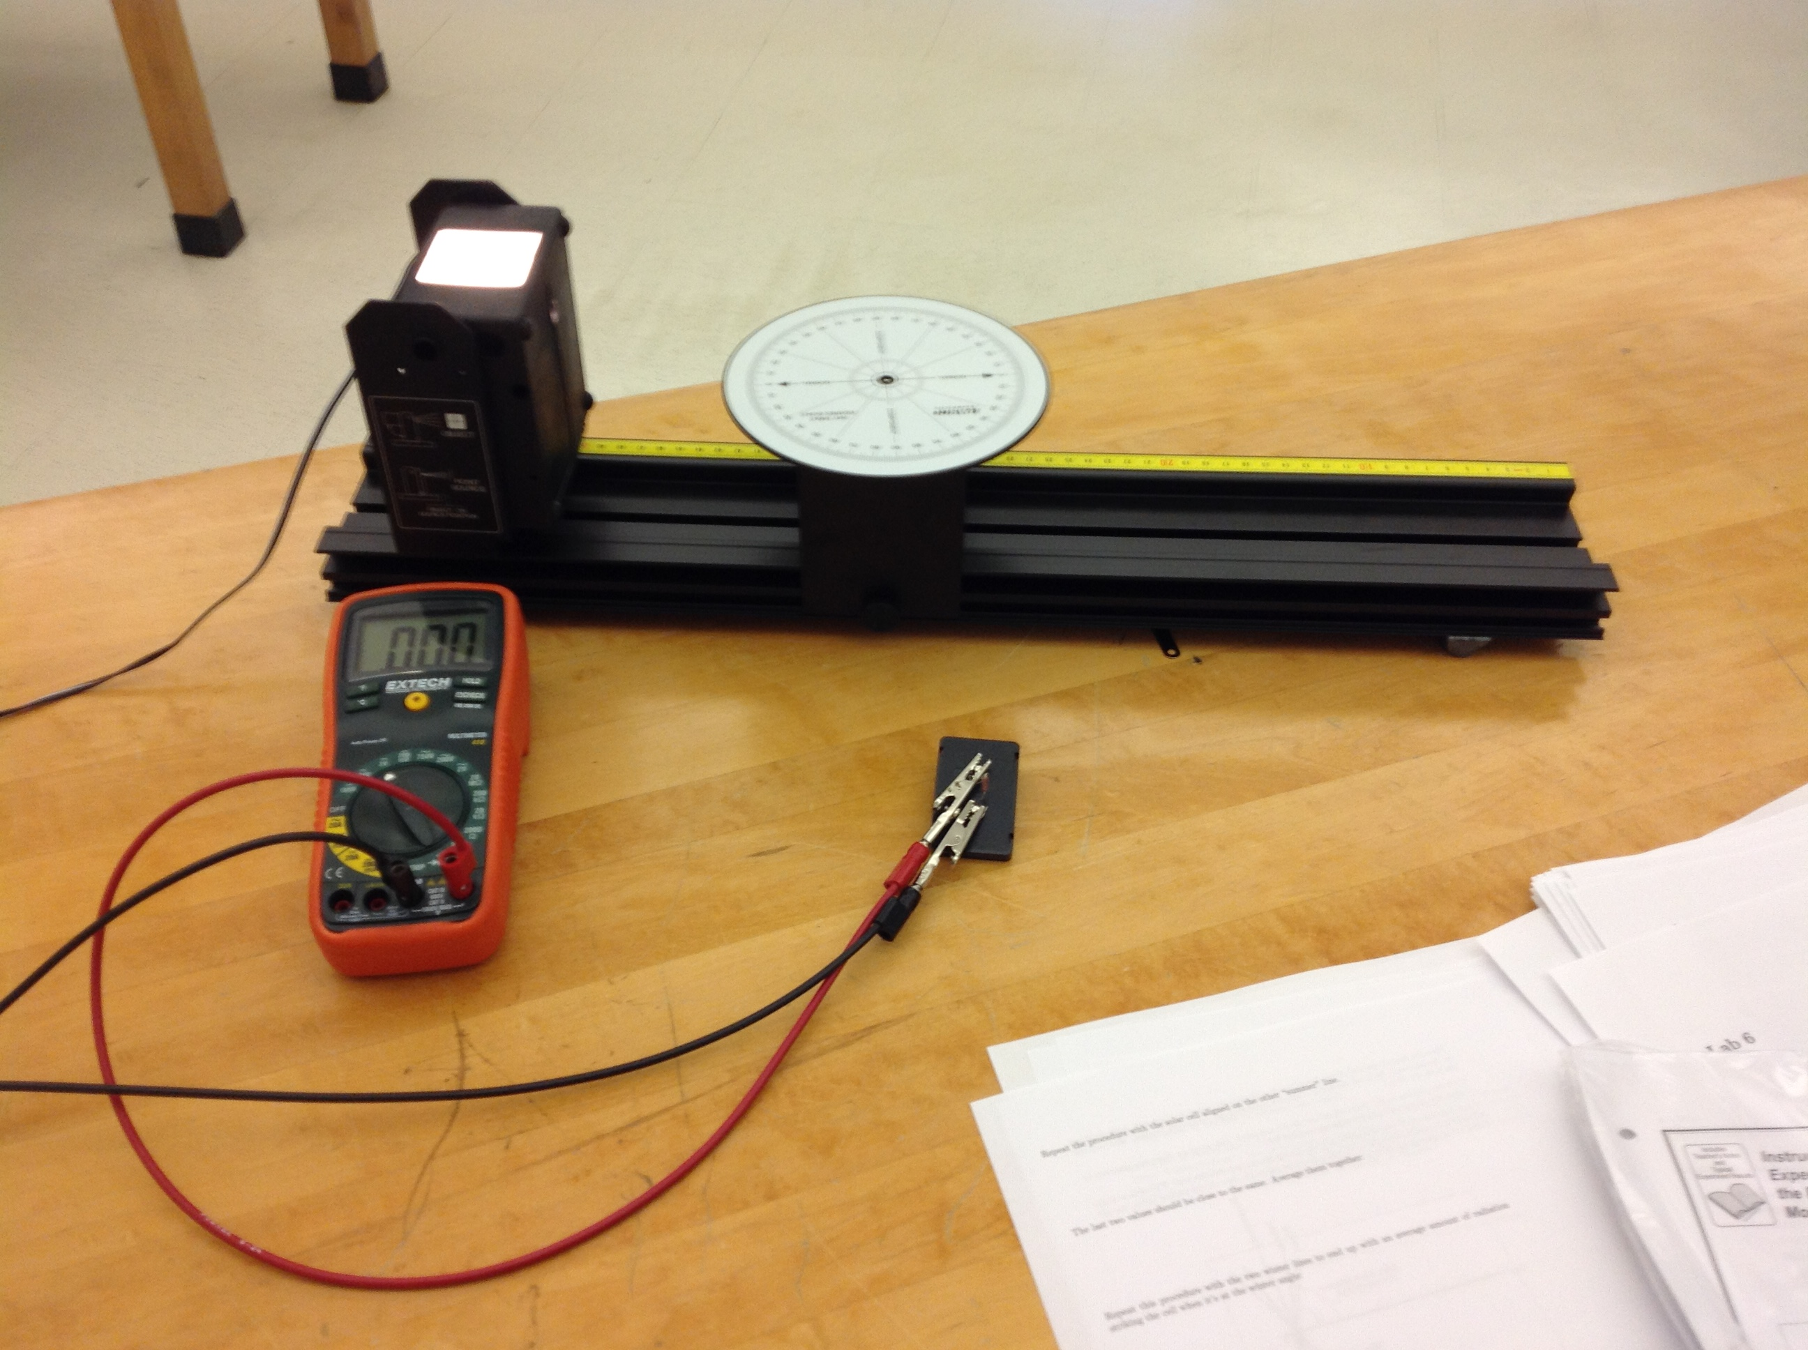

6. Celestial navigation

iPads.

7. The Moon.

Nothing (except PCs).

8-10. Motion of planets, Kepler, phases of Venus

iPads.

11. Masses with Kepler’s 3rd Law.

Nothing.

12. Spectra of light sources.

Handheld cheap spectroscopes.

Different kinds of light sources (one of each, distributed around the room – not one per group):

* Overhead projector.
* Candle.
* Hydrogen discharge lamp.
* One other discharge lamp. (Sodium? Neon? Doesn’t really matter.)
* Bunsen burner, salt, some sort of spatula so that I can put a bit of salt into the flame from time to time. (I’ll staff this station for safety reasons.)

13. Diffraction grating.

Same as 132 lab with the same name. (Laser, grating, way to set it up to produce a visible pattern on the wall, ruler / meter stick.)

14. Spectrum of hydrogen.

Same as 132 lab “The optical spectrum of hydrogen.”

15. Refraction and lenses.

Small whiteboard

Ray optics demonstration set (box with lenses, etc., that sit on the whiteboard).

Laser Ray Box (light source that goes with the above.)

16. Image formation by lenses.

Same as 132 lab “Refraction at spherical surfaces: thin lenses,” except that we only need one converging lens (and no diverging lenses).

17. Refracting telescopes.

Telescope kit (cardboard tubes, two lenses, the bits of cardboard, plastic, and foam that hold the lenses in place). Just giving them the disassembled components is good – make them figure out how it goes together.

18-19. Nothing needed.

20. Parallax.

Spectroscopes (the ones used for the hydrogen spectrum lab that let you measure angles accurately).

Rulers.

Masking tape.

Tape measure (1-2 for the room is fine.)

21-30. Nothing needed! (All computer labs.)